# Background

There are two commercially available ergonomic keyboards that are split into two parts to make it easier to position them. One of the keyboards is available with an accessory that provides adjustable tenting angles, which can reduce the forearm pronation caused by flat keyboards. The purpose of this project was to create a similar accessory for the keyboard that doesn’t have an adjustable tenting angle accessory.

# Requirements

* The device should be able to put the R-Go Split keyboard into a tented angled orientation when split into two parts.
* The keyboard can be set to tenting angles of 5, 10, and 15 degrees.
* User should be able to easily adjust angles and remove device to use keyboard flat.
* When in use, keyboard should be stable.

# Research

## Existing Designs

The R-Go Split Ergonomic Keyboard (<https://www.r-go-tools.com/products/ergonomic-keyboards/r-go-split/qwerty-us-black-wired/> , $<https://www.r-go-tools.com/products/ergonomic-keyboards/r-go-split/>) is commonly recommended by the AT specialists within Neil Squire Solutions for clients. It is very thin, and because it is split, each hand can be positioned in an optimal position. It also requires very little force to depress the keys.

The Kinesis Freestyle2 Split Ergonomic Keyboard (<https://kinesis-ergo.com/shop/freestyle2-for-pc-us/>, $99 USD) is another split keyboard. It has an optional accessory for tenting called the Freestyle2 V3 (<https://kinesis-ergo.com/shop/freestyle2-v3-accessory/>, $26.95 USD).

# Initial Design – V1.0

The initial design was heavily based on the Kinesis Freestyle2 V3 Tenting Accessory and modified to be compatible with the R-Go Split Ergonomic Keyboard and designed to be 3D printed instead of injection molded.

This design consists of three main bodies: a clip, a short arm, and a long arm. The clip attaches to the R-Go Keyboard. The short and long arms attach to the clip. The tenting stand provides a 5-degree tenting angle when both arm are open. The short arm and long arm can then be attached together to provide the other tenting angles. It provides a 10-degree angle in one position, and a 15-degree angle in the other position. The arms consist of multiple bodies that are glues together to provide flat surfaces for quick printing without needing support.

Figure 1: Initial Design – 5-degree Configuration

Figure 2: Initial Design – 10-degree Configuration

Figure 3: Initial Design - 15-degree Configuration

## Arm Attachment

The original design uses a snap-fit clip to attach the two arms together. We attempted to use a 3d printer compatible snap-fit into this design, but were limited by the available space and managing the strength/durability related to print direction.

Figure 4: Initial Snap Fit Design

As an alternative, a design incorporating magnets was used to provide some locking force for the arms. The limited space available based on the geometry between the different configuration of the arms limited the size and number of magnets that could be used. The magnets were inserted within 3d printed components by pausing the print and super glued into place. This technique worked, but there are several drawback. First, not all printers are able to easily pause prints to allow the magnets to be inserted. Second, the method requires manual intervention during the printing process and is prone to error (i.e., the magnets must be installed with correct polarity).

## Opportunities for Improvements

**Function - Arm Attachment Mechanism**

Initial snap fit didn’t work reliably and wear away after a small number of uses. Magnets don’t provide enough locking force.

**Assembly**

Assembling the arms into the clips is difficult, as the pins are in different directions and requires the clip to be bent and contorted.

The arms consist of multiple components that need to be superglued into place.

**Stiffness/Durability**

Don’t have much feedback on the devices that have been created and in use, but unsure if they will stand up to rough usage.

Clip is too small. The portion of the clip that has the hole for the arm’s pin is too small.

Figure 5: Area of Clip That Is Too Thin

## Improving Existing Components

**Clip:** Use the same clip, as it works, but add a small hole in the centre for a printed pin insert to spread the hinge pins into place.

**Arms:** Fill in the empty space on the side with the smaller foot so they can be printed as one piece. Arrange pins to face the same direction and add space for the pin.

# Version 2 - Ideation

The proposed device features a toothed locking mechanism conceptualised from an old beach chair ratcheting mechanism, or similarly, the locking mechanism on an ironing board.

[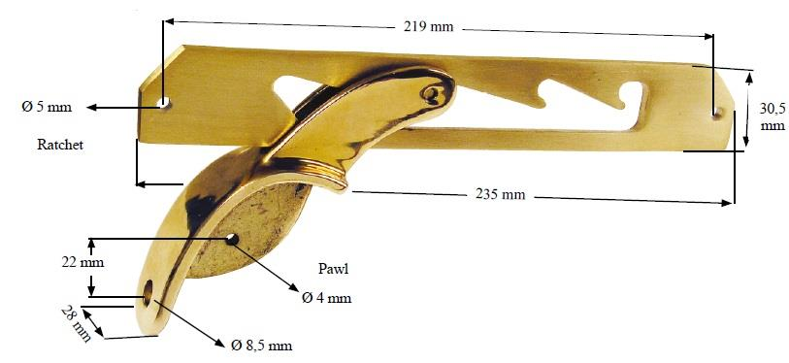](https://woodworking.stackexchange.com/questions/3805/beach-chair-reclining-arm-mechanism)

## Ideation of components

**Clip:** The clip onto the keyboard the current design features works well. This can be implemented into the new design, but extending it out to hold the entire keyboard, and moving the hinges to the side. This clip will have a hinge on one end to attach to the base, and legs on the other end.

**Legs:** The height of the legs is determined through the max angle of 15 degrees, where the legs will be perpendicular with the base. Originally the legs were two separate pieces with snap fits to hold them on, but joining them into one piece allows them to move as one, making the device more use friendly. Joining them also allows them to hold onto the clip by their own rigidity. The legs are triangular so the ‘foot’ will be able to lock into the ridges easier at narrow angles.

**Base:** The base features ridges for the legs to rest on to create different angle, and a hinge for the clip to fit into. To secure the clip to the base, there are notches under the base for zip ties or string to wrap around the entire hinge.

# Version 3 – Ideation

This design resulted from a meeting with Jake on the previous two designs. It functions intermediately to the two designs and features a clip on base, with two sets of legs that attach at a hinge. When folded down, the legs put the keyboard on a 5 degree angle, and 10 or 15 degrees when either of the legs is folded out.

# Prototyping

Version 1:

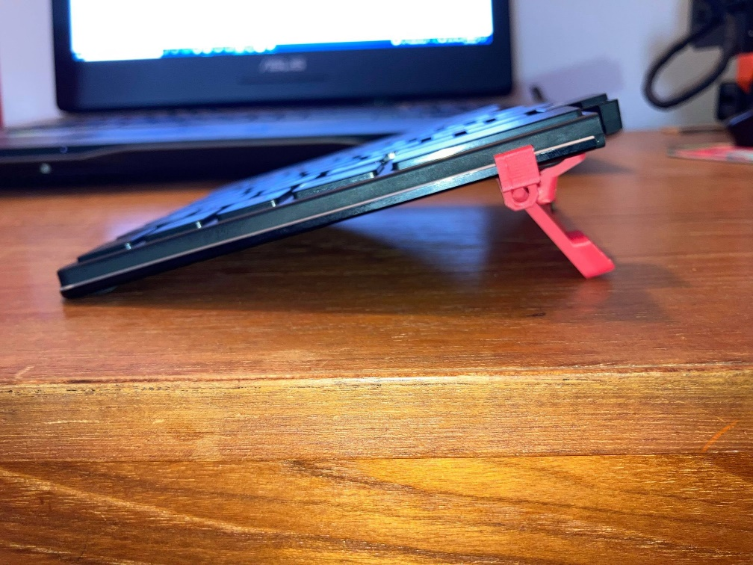

Version 2:

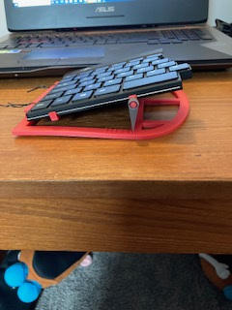

Version 3:

# Final Design Selection

The following chart shows the key elements of each design and ranks them as either better or worse than the other.

|  |  |  |  |  |  |  |  |
| --- | --- | --- | --- | --- | --- | --- | --- |
| Design | Print Complexity | Print Time | Assembly Complexity | Stability | Compactness | Adjustability | Ease of Locking into/out of Position |
| V1 | Worse | Better | Worse |  | Better | Worse | Worse |
| V2 |  | Worse | Medium |  | Worse | Better | Better |
| V3 |  | Medium | Better |  | Medium | Medium | Better |

Based off feedback from OT’s with Solutions, the Version 2 (ratchet concept) stand was selected.

Changes made to the Final Design:

To improve the stability of the stand at angles, the interface between the legs and base are a rounded leg and a series of “cups” on the base the legs fit into. A tab was also added to the legs for easier adjustment of the stand.

Craft foam was used to cover the bottom of the base to reduce slipping along the surface when typing.

The inner edge profile of each base was modified to provide support to the parts of the keyboard halves that extend further into the middle, while also being able to nest together closely.

Due to the different lengths of each keyboard half, when tented with the outer edge as the fulcrum point, the inner edges of the keyboards are at different heights. At higher tenting angles, this is increasingly noticeable. This can cause discomfort in use as it might cause someone to sit with their shoulders at different angles to compensate, it also may reduce rejection of the device.

# Opportunities for Improvement

Ratchet: Size reduction

# Credited Resources Used In Development

1 R-Go split Keyboard